__________________

MODELING AIRCRAFT
with 3Dmax-R3
BOOK 1

__________________

Jean.Sabatier@pixup.com
Member of ROTW

Table des Matières

1. FOREWORDS 1
2. WHAT DO YOU NEED 2
2.1 3D Tool 2
2.2 Image editor 2
2.3 Aircraft data 2
3. GENERAL CONCEPTS 5
3.1 Overall process 5
3.2 Some definitions 6
4. FUSELAGE BUILDING 7
4.1 Setting full view 7
4.2 Displaying a background view 7
4.3 Building Steps 9
4.4 Body sections 10
4.5 Initial cylinder 11
4.6 Positioning 14
4.7 Extrude the body 15
4.8 USING FDD2 OPERATOR 16
4.9 Displaying progress 17
4.10 Improving the nose 17

FOREWORDS
This document describes a method to design 3D aircraft model for FLY!. There are certainly other various ways to design aircraft, however, this one works well for all aircrafts I have built until now. Although illustrations are based on 3Dmax and Photoshop, this method would work with any others 3D tools that have similar capabilities (I am thinking of Truspace and Paintshop among them).

Modeling will be based on mesh editing, and common operators like extrude, Boolean operations and a few others. No vector (NURB) operations will be used, so as to keep it simple.
Although I will often describe some manipulation in a detailed fashion, it is expected that the reader has basic knowledge of those operations.
- Mesh editing
- Creating basic object (cube, cylinder,)
- Selecting object, edge, vertices, faces
- Extrude
If not, it is suggested to search the WEB on the keyword ‘3Dmax”. A lot of tutorials are available (www.3Dcafe.com) and it is strongly recommended to practice 2 or 3 workshops to acquire this basic knowledge.

One last word: be kind enough to bear with my English, this is not my native language.

WHAT DO YOU NEED

3D Tool
Obviously, you need a 3D tool like 3Dmax, Truspace or similar. With such a tool, you will design the external 3D view and parts. Then you will learn to texture each part and animate them. Finally, this tool will be use to export the S3D file for input to the FLY ! Keyframe editor.
Be sure that the 3D tool can export the S3D format, as this is the only format supported by the Keyframe editor.
Now, if you have 3Dmax, there is 2 free plugging that are necessary
- Texporter. This plugging will draw a blueprint of any part, so you can paint over it.
- Polyshop: This plugging will optimize the mesh for any part. So you can draw in a good resolution and simplify latter.

Image editor
You will need an image editor like Paintshop or Photoshop or similar. The image editor is used to paint the textures or to prepare textures from real photo, and is used a lot.
Be sure that your image editor support indexed color mode, as this is the mode required by the Keyframe editor.

Aircraft data
To model an aircraft, it is almost required that you have a 3 view of it. Then some good pictures will also help.
3D view
So, try to get an electronic 3 view (Top, Side, Front) of your aircraft, from any source (WEB, Books, manual, others) and put it in your computer.
If you have good pictures from side and front, you can outline then with the image editor and make good side and front view.
Assuming the photo is a good side picture
- Open the picture in the image editor
- Create a new layer
- Use the LASSO (Photoshop) tool to outline sections of the picture
- Use a red color
- Use the STROKE in EDIT menu to draw the outline
When done
- Delete the background layer
- Save the layer as Rightview (or LeftView)
Often you will find 3 view in one document in GIF or JPEG format. Use the image editor and separate them in 3 distincts pictures. Resize them into the 1024 or 768 using proportional constraint (dont change the XY ratio when resizing). From now, we assume that we work with the following files:
- FrontView.png
- RightView.png (it can be a LeftView)
- TopView.pgn
Save them as PNG because this is the most compressed format. It will save place into the 3D tool.
TIP on organization.
Create a directory under 3Dmax. Name it according to your aircraft (Connie for instance). Put all pictures, views and textures into this directory.

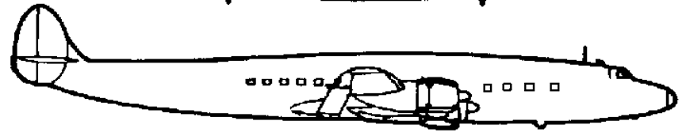Here is a RightView drawing
Pictures
If you intend to do real photographic texturing, then you need some good pictures like
- A side view of 1024-768 minimum
- Several good close-up of individual parts (landing gear, nose, engine, etc)
We will see how to made good use of them latter

GENERAL CONCEPTS

Overall process
Just to give you an idea of what you are into, here is a general overview of all the steps needed in the good order:
- Fuselage building
- Windshield cutting
- Tail building
- Texturing the fuselage
- Wing design
- Stabilizer
- Flaps and moving surfaces
- Gear apparatus
- Pivot alignment
- Linking part
- Animation
- Texturing
- More

Some definitions
Here is some terminology I will use from now

Term | Definition
Mesh | The set of vertices (points) that are draw to define an object
Operator | One of many functions in 3Dmax that results in an action onto the selected item
Viewport | A window displaying the model in the 3D tool

FUSELAGE BUILDING
OK, we now start from scratch, open the 3D tool and face a blank page. We start with learning how to display a background view. This process will often be used during the modeling .

Setting full view
We want to work with only one viewport in full screen mode (except the tools bar) corresponding to the side view we have (a right view)

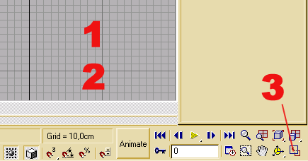MAXIMIZE A VIEWPORT
- Click on any viewport
- Type R. The viewport become a right viewport (note)
- Click on the MIN/MAX toggle
You should have one viewport in full screen (except the bars) with the name RIGHT in the upper left corner.
NOTE: To change the orientation of a viewport, it must be selected and you type one of the following letter
R =right, L = left, T = top, B = bottom, F = face, K = Back, P = perspective

Displaying a background view
Here is the process with 3D max to display a background view.
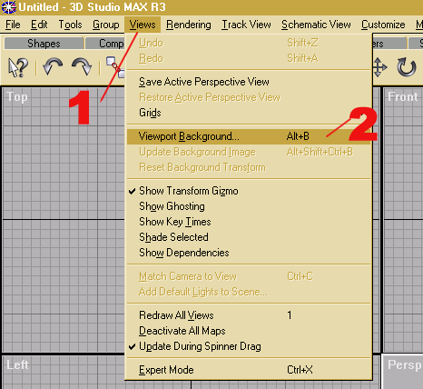
DISPLAYING A BACKGROUND PIC
- Click on VIEWS menu
- Click on Viewport Background

A dialogue box is displayed

SETTING PARAMETERS
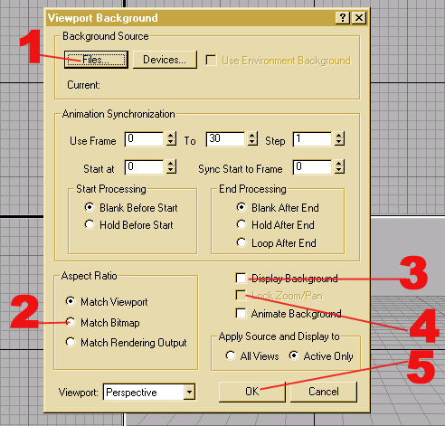

- Click and select the file RightView.png from where you stored it.
- Check MATCH BITMAP (see note)
- Check DISPLAY BACKGROUND
- Check LOCK ZOOM (See note)
- Click OK
Note
MATCH BITMAP is the option that gives the correct aspect ratio of the picture. This is important for the correct proportion of the plane. It should always be on.
LOCK ZOOM, when set will synchronize the background and the model. When the model is moved or zoomed (with the viewport operators located in the lower right bar), the background follows the transformation. When unchecked, then the background stays fixed in the view port. You will have to play with this option a lot during the building process.
- LOCK ZOOM ON when you have to center or position or zoom the background picture
- LOCK ZOOM OFF when you want to place the model over the background until they match.

Here the RightView.png is displayed as a background picture. It is correctly zoomed. I have it positioned in the upper part of the viewport to save some place. Normally, you should center it in the middle of the screen.
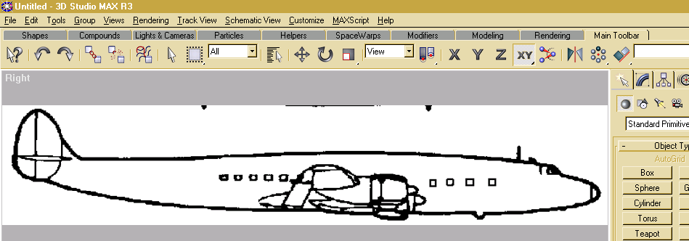If you find that drawing over this is not very convenient, then either
- Go back to image editor and paint the background in a grey tone
- Change the 3Dmax background in Customize Preferences

Building Steps
Here is the general procedure to build the fuselage

Step | Description
1 | Draw a cylinder with only one section and 16 or 18 sides depending on whether the aircraft sides are flat or rounded. Place this on the center part of the body
2 | Extrude the forward sections of the plane. Make several sections until the tip of the nose is reached (see further)
3 | Extrude the rear sections of the plane. Make several sections until the rear tip of the body is reached.
4 | Shape the top of the model according to the top view
5 | Shape the side of the model according to the side view
6 | Shape the nose
This is the final result of this process. In the following chapters we learn in more detailed description how to achieve this result
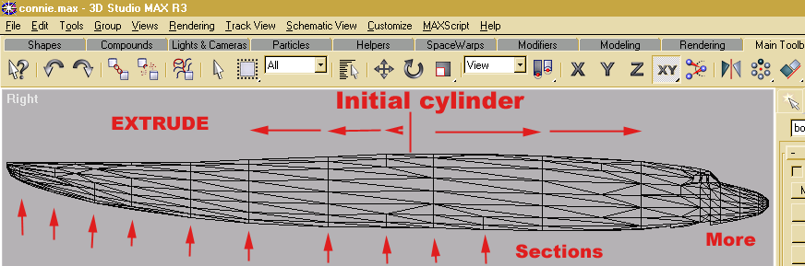

During the whole modeling process, we don’t care about the real dimensions of the aircraft. What we care about is the relative proportion between parts, and for this, we use the 3 views we have. As a consequence, we don’t care about unit (feet or Meters) until the aircraft is almost complete so that we can set the real dimensions.

Body sections
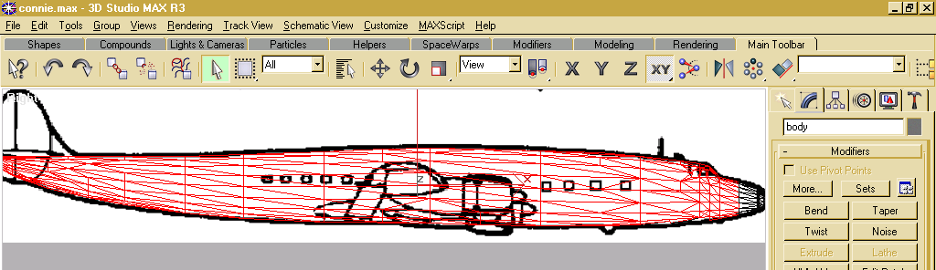The pictures shows the final result after cutting windows and traps, and some optimization explained latter. The model matches closely the side view.
As you can see, there are several vertical sections in the body model (some are partly removed by the optimization process). To build the body, we start with a cylinder in the middle of the body. Then we extrude the right face to build the forward section. And then do the same to build the rear section.
A vertical section is generated each time you stop the extrude process. At the end, we have one cylinder with many vertical sections. To evaluate how many sections we need, we apply the following rules in that order
Rule 1
Make a vertical section at points where the body curvature change. The Connie above is more complicated than modern jets because of the body curvature. There is about 7 sections in the mid part to render this curvature. To make a roundish nose, there is also more sections in the nose part than in the mid part.
TIP : You may go back to the image editor and mark the side view where you intend to have vertical sections. (save a copy of the original)
Rule 2
We may optionally define other vertical sections between the wing leading edge and trailing edge. This will latter help to design the jointure between wing and body.

Initial cylinder
Let us build the first cylinder (future body). We detail this operation as a general example for all other similar steps.
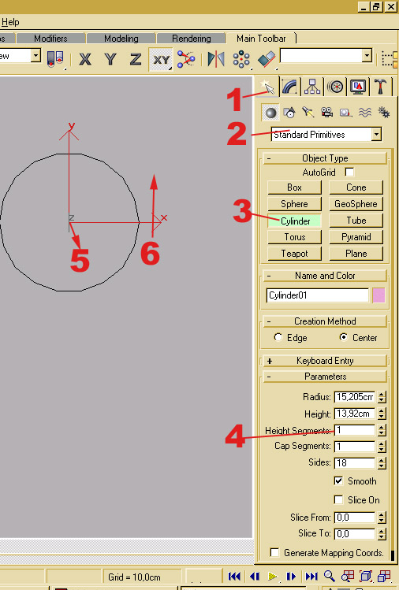
- Click the primitive TAB
- Select STANDARD PRIMITIVES
- Click CYLINDER
- Change to 1 HEIGHT SEGMENT
Drawing a primitive is done in 2steps. You draw the face (X, Y for instance) then you extend the 3rd dimension (Z). Do not release the mouse during this 2 steps
- Click where the center should be, hold the left button and drag until the diameter is OK. Do not release the left button then execute next step
- Drag up to give some 3rd dimension to the cylinder.

NOTE: Do not try to get the good size while drawing an object. There are a lot of easiest ways to do it.
After drawing a basic object, do not click again on the screen, because it will start another object. Click ESC to cancel drawing if you did.

The next thing to do after drawing a basic object is to convert it in EDITABLE MESH. After that, all components (vertices, edges, face) can be edited with the operators.

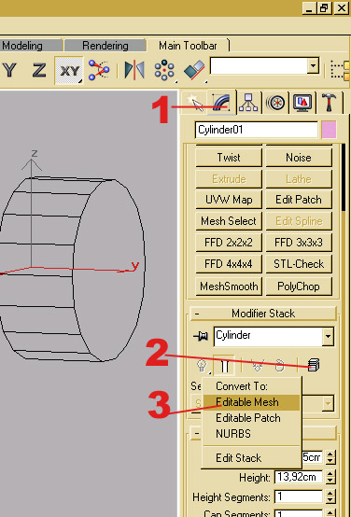MAKE AN EDITABLE MESH

- Click the operator TAB
- Select the object and click the EDIT button
- Select EDITABLE MESH on the displayed menu

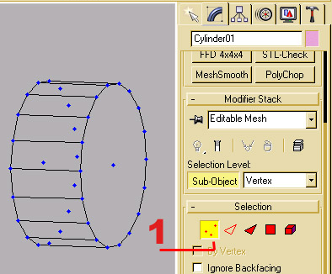

Now you can edit any component by clicking on the corresponding button. The related components are displayed with visual focus (here the vertices).
Next thing is to name the object as a part of the future aircraft, so we name it “body”.
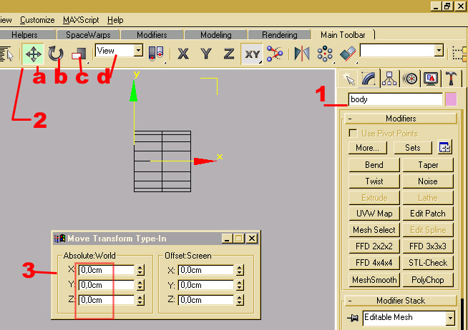We also center the body part in position (0,0,0) of the world coordinate.

- Enter the part name “body”
Now to center the part
- Click over the MOVE operator to select it
- Right click again over the MOVE operator. A coordinate box appears. Enter 0 in all 3 directions. Use the left windows so as to enter the WORLD coordinates.
The body part is now at WORLD origin. This will be useful when we need symmetrical copies latter on.
NOTES:
While we are on this screen, let us review the useful operators that will be used a lot of time. Remember that all those operators affect the selected object and not the viewpoint. We shall see latter other functions that affect the view point but not the object.
OPERATORS REVIEW
- Is the MOVE operator. It will move to any direction the selected component (Object as a whole, vertices, edges or faces). To lock a direction, click on the X, Y,Z on the left. To move an object, click on the displayed axis associated with the object and drag & drop the selection.
- Is the ROTATION operator. It will rotate the section about any axis. To rotate a selection use the same drag and drop method as above
- Is the SCALE operator. Several SCALE operators are available by clicking on the small lower right spot. We use UNIFORM SCALE (square icon) and NON UNIFORM SCALE (rectangular icon). UNIFORM will scale the selection in all 3 directions, while NON UNIFORM scales in only one direction.
- D is not an operator but select in which system coordinate the operator works. We mostly use WORLD and LOCAL. WORLD is for modeling while LOCAL will be used for animation.

A more precise way to define a transformation is to select the operator and right click over it. A coordinate box is then displayed and you can control the amount of transformation in each direction by typing numbers. Personally, I use the drag and drop method for modeling and coordinate box for animation.

Positioning
We position the body part over the side view of the aircraft.
- Display the background side view of the aircraft as described before
- Move and scale the body part to position it and make it mach with the picture
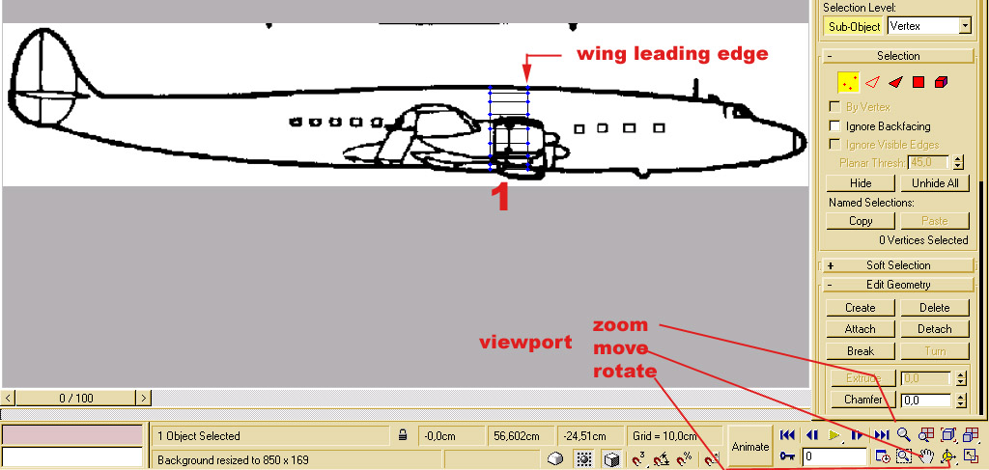NOTE:
- First set the RIGHT view port by typing R in the view port
- Position the background view until it fills all the view port. For this, use option LOCK ZOOM when displaying the background and use the viewpoint operators in lower right part of the MAX screen. Use only the MOVE and ZOOM operator. For this step, you don’t care about the body part.
- Go back to VIEW BACKGROUND and uncheck LOCK ZOOM option. Now, the viewpoint operators affect only the view while the background stays fixed. Using the view port operators position the body part and scale it uniformly until the forward section is approximately on the leading edge of the wings. Scale until the body diameter matches the picture.

SAVE YOUR WORK NOW!!!

Extrude the body
Here we look into the extrude process for the first section of the body. For clarity, the background picture is omitted, but you should have it permanently displayed during this step. Do not move the view point as it take time to adjust the match between model and background image. Go back to VIEW BACKGROUND and ensure that LOCK ZOOM is on. If you move the view inadvertently, then the model will stay synchronized.
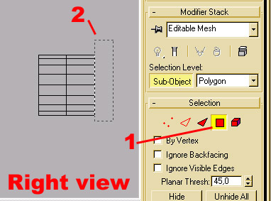The view port is in the right view.
- Select the face level
- Carefully select the vertical face of the forward section
NOTE: If you select extra face, hold ALT and click on it again to deselect it.
Or click elsewhere on the screen to deselect all.
Alternate way is to go to back view port, select the face, then realign the model over the background picture but this is rather cumbersome.
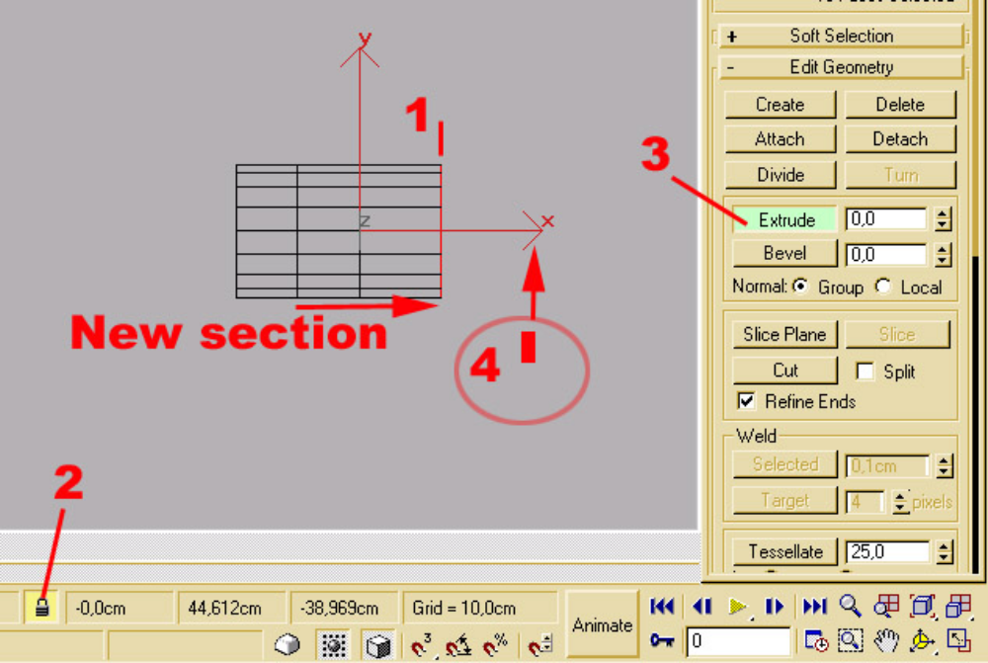
- When selected, the vertical face is displayed in red color
- Lock the selection so you will not loose it if you click elsewhere on screen
- Activate the EXTRUDE operator
- A specific cursor is displayed due to the locked selection. Click on screen an drag the cursor up. The new section is generated on the screen. Stop extruding when you reach the next mark on your side view or the point where curvature changes (see previous chapter on this subject).
Before processing to the next extrusion, you can adjust the selected face along the X-axis with the MOVE operator (Main Bar). In fact, I should have selected WORLD coordinates in the main bar, so the Y-axis would be the one to move along. It is better to model in the WORLD coordinates than in the VIEW mode, because they may differ under certain conditions. Do it now.
Repeat the extrusion until the last forward section reaches the nose tip. When done, unlock the selection (2)
Then do the same procedure for the rear part of the body.
When done, SAVE YOUR WORK.

Shaping the fuselage
To shape the fuselage, we use both the side and top background view.
Make a copy of your file to save the original cylinder. You may want to restart from here.
We start with the top view, because it is symmetrical and we can learn some basis technique. You are now enough experimented to do the following 3 steps without detailed explanations.

- Set the top view port
- Display the top background view
- Match the body cylinder over the picture

In the next chapter, we are using the FDD2 operator to shape the body according to the view.

USING FDD2 OPERATOR
The following sequence of pic illustrates how to use this operator to shape any part of an object
(Background view is not displayed for clarity)

STEP 1: FDD2 preparation
- 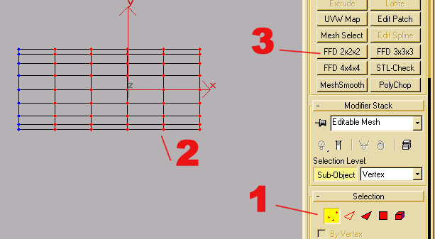Click the vertex level. All vertices are displayed in blue
- Select the set of vertices that must be shaped. They are displayed in red.
- Click the FDD2 operator

STEP 2 SHAPING AN OBJECT
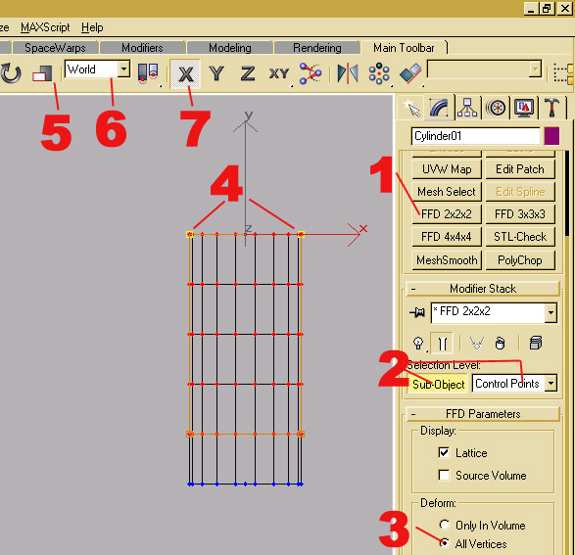
Here we display a top view port to illustrate how to shape the forward cylinder part as a nose.
- Once the FDD2 operator is active, the set of selected vertices become circled with a box with orange corners and edges. This box is named the GIZMO
- Click on SUB OBJECT and select CONTROL POINTS.
- Check ALL VERTICES
- Select the 4 forward corners of the GIZMO. They become yellow (active)
- Select the NON UNIFORM SCALE operator
- Select the WORLD system coordinate
- Lock the X direction as we are going to crush the cylinder in this direction only.
STEP 3 CRUSHING THE NOSE
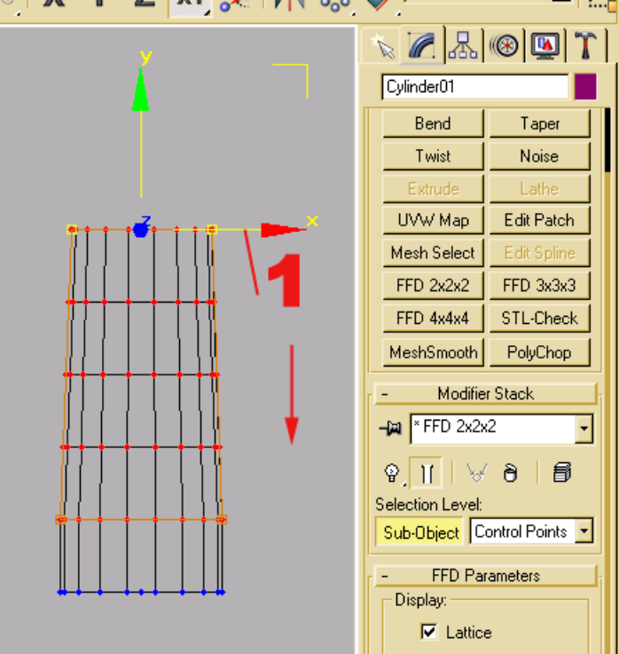
- Set the cursor over the X-axis. Left click and drag it down (or up) until you get the right amount of crushing. Do not release it until it is OK.
- You may delete the whole FDD2 process by clicking to the trashcan under the window FDD 2X2X2. There is also a stack for the nth last commands. You can delete them with the EDIT menu, item UNDO.

Now when you are satisfied with the result, right click on the view port and select COLLAPSE STACK. The modifications are committed and the GIZMO disappears.

Repeat STEP 1,2,3 and select one less row of vertices (the bottom one), until you are done.
Here is what you should have after shaping the top part.
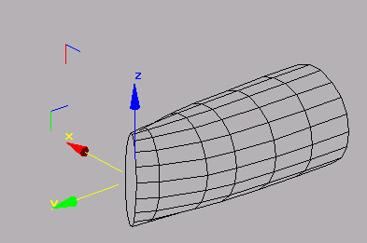
Note
We have shape the nose according to the top view. So the height is still flat.
Repeat this process until the model closely matches the top background view.
When satisfied, make a copy of your file.

SHAPING THE SIDE
Then we proceed to shape the body according to the side view, with the same method (STEP 1,2,3)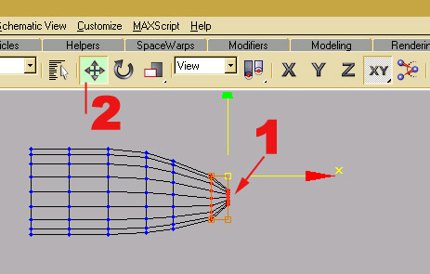 by selecting a set of vertices, deform the whole set, then proceed with one less row. We also learn some variation.
The nose profile is not always symmetrical in the Z direction. So you may
- Select only one set of corner (top or bottom) of the GIZMO
- Use the move operator to align the top/bottom of the model onto the background side view.

The nose depression is done as the last step, again with the FDD2 operator.

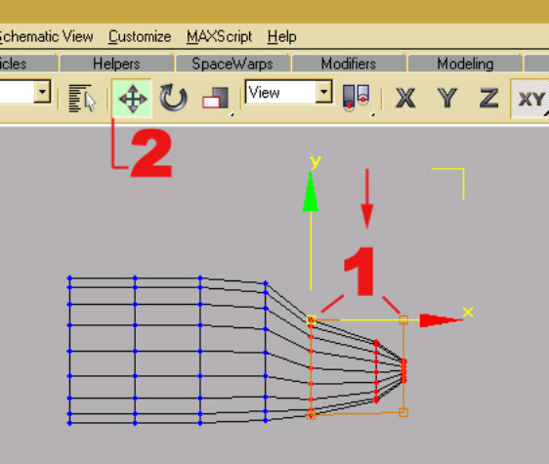
- Select the nose vertices, click the FDD2, select CONTROL POINT and select the 4 top corners of the GIZMO
- Crush down the nose with the move operator

Optionally, you may have to rework the nose part to exactly match the background side view. Do this with the FDD2 operator and selecting only one vertical section at a time.
The FDD operator has the advantage over scaling that the selected vertices are proportionally modified with the transformation. Never use individual vertex in a transformation. Always use the paired vertex to conserve the lateral symmetry of the body.
I have used only 4 vertical sections for illustration. You may have more sections in the nose part if you want a better looking nose. Nose is very important as, most of the time, you can name an aircraft by seeing just the nose.

TIP. Check often the perspective view of your aircraft. Rotate and move the view port for this. While transforming the side view, you may have selected extra vertices and introduce some defect somewhere else. One secret is to modify any error as soon as possible. This is also why it is important to make copy (with Explorer) of the progress (a distinct operation that saving file). You can always restart to a good previous step.

Displaying progress
You need to frequently display your progress just to make correction ASAP.
Here is the process with 3Dmax.
Before we display our work, we
- Assign a SMOOTH group to the faces.
SMOOTH group will act on the rendering process. It just does as the name implies. The cylinder will look round, rather than a set of distinct faces. However, this is just for local view in 3Dmax. There is no impact on the way the plane will be rendered in FLY !. If we assign different SMOOTH groups to the same object, the jointed faces will look separated.
- Assign a blank color (or any light color) just to detect visual defect.
ASSIGN A SMOOTH GROUP TO FACES
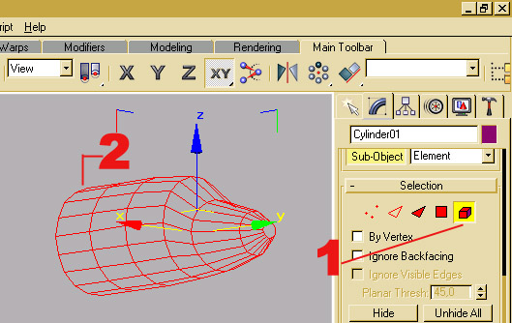We start by selecting the set of faces to smooth
- Select the part and click on the ELEMENT level
- Click on the object

The selected faces are displayed in red color. Here the whole part is selected because we choose the ELEMENT level

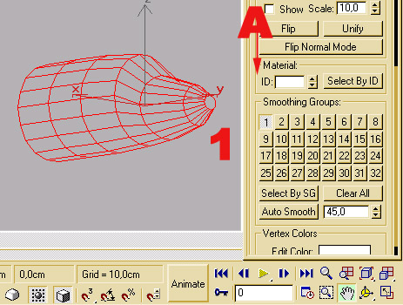
- Move the left bar all the way to the bottom. Left click on an area without button and drag down.
Assign SMOOTH group N°1

We have assigned a SMOOTH group to all the faces of the body.

ASSIGN A COLOR TO AN OBJECT
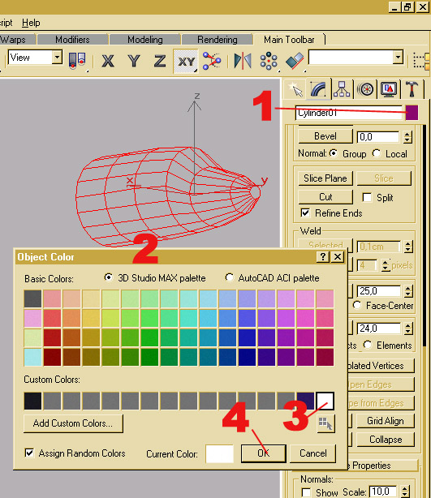
Now we assign a color.
- Click on the color tab.
- A dialogue box is displayed
- Select the blank color (or any light one)
- Click OK to assign the selected color to the object.
NOTE: The color is assigned to the whole object. It is not possible to assign several colors to the same objet. Color stayed assigned until changed, even when the object is textured. Color is just a local matter to 3Dmax and is not exported to FLY.
Only Textures are exported as we shall see in further sections.

RENDERING THE SCENE
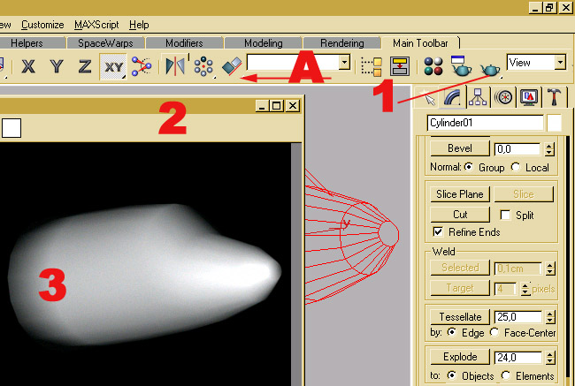
- Move the Main BAR to the left until the rendering operators are in view
- Click on the rendering button
- An image of the scene is displayed.

Now you can render different aspects of the body, zoom in or out and try to detect visual defects.
On this view, we notice that the rear part look retracted. This is an artifact of the SMOOTH group. As we have assigned the same SMOOTH group to all faces, including the rear face, the rendering engine try to give a roundish look. This we correct in the next step, to illustrate how to work with this feature.

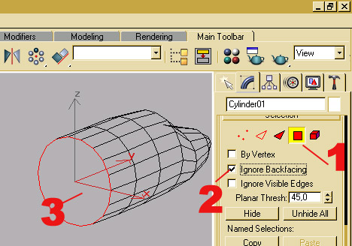
Rotate the view port until the rear face is displayed
- Select the object and click on the FACE level
- Check the IGNORE BACKFACING option
- Click the rear face to select it. The rear face is now displayed in red.

NOTE: IGNORE BACKFACING when checked restricts all selections to the visible component (vertices, edge and face), as see from the view port. In this example, when clicking on the rear face, the system may select a face located on the left. This is avoided by checking this option. You will have to use it a lot of time during the modeling process.

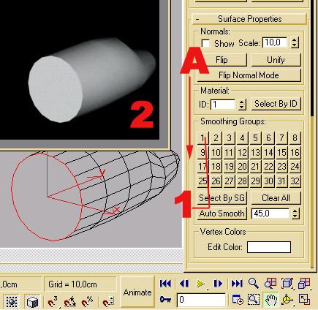Now go down the left BAR (A)
- Unclick SMOOTH group N°1. This unassigns the group from the selected face(s).
- Go up to the Main Bar and click on the render operator. Now the rear part has a clean cut.
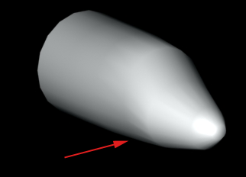

From the right pic, we can see small glitches. Part of it comes from the small number of vertical sections I did put in this model. Next we examine some ways to improve or better shape the nose part.
But before SAVE your work.

Improving the nose
We first deal with the general shape of the nose, before going into smaller improvements. As a rule, always start from general to particular for this kind of process.
Here are some meshes for nose of different aircrafts. They all look different.
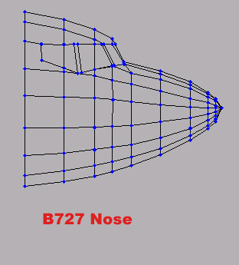
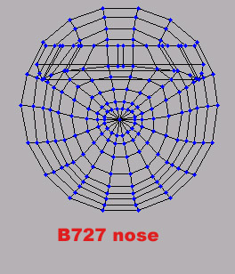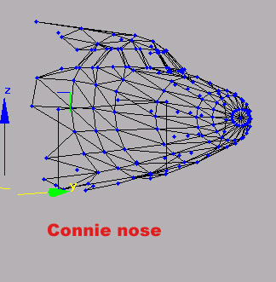

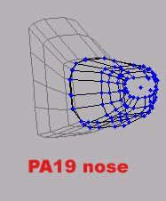The B727 nose is slightly triangular, while the Connie nose is kind of elliptical.
The PA19 nose has a square shape.
We try now to give a triangular shape to our model, using again the FDD2 operator
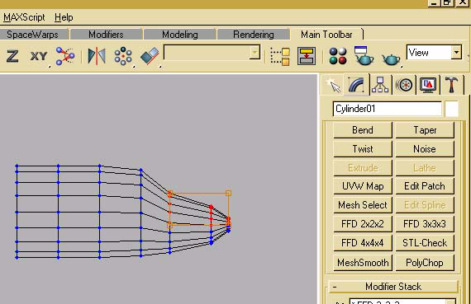

Select the object and the vertex level.
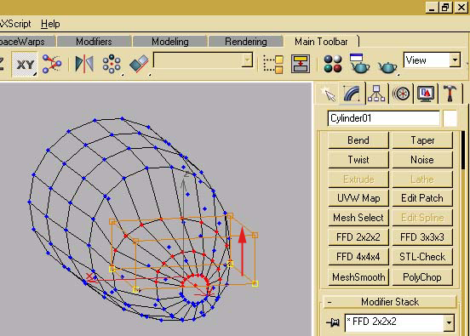Then select the upper vertices as illustrated and click on the FFD2 operator. The selected vertices are enclosed in the GIZMO.
Set CONTROL POINT for the FDD2 operator and select the bottom corners of the GIZMO.
Then move up the bottom of the selection to flatten the nose upper part.

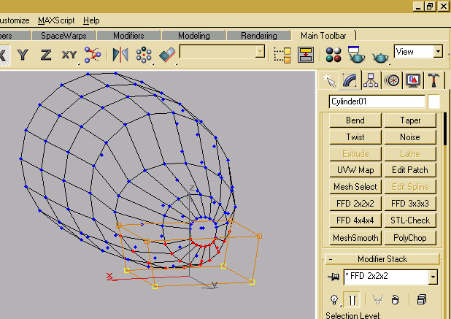Then select the bottom vertices, click on the FDD2 operator and select the bottom part of the GIZMO.
Pinch the selection using the NON UNIFORM SCALE operator in the main bar.
Render for visual check
Check that the modification still match both the side and top background views.

SMALL ADJUSTMENT

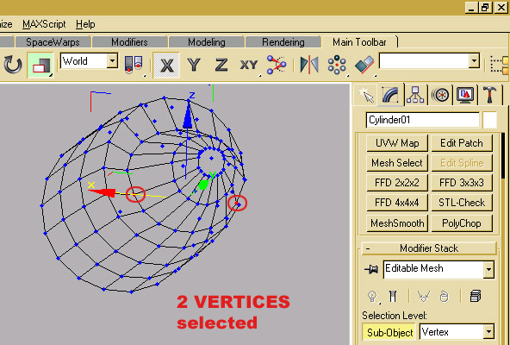Now when you detect some vertices protruding too much, select them (vertex level) and use the MOVE or SCALE operator to correct them.
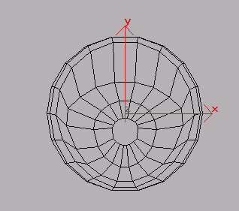
The nose has now a triangular shape. On the above picture, it also need some additional correction. The lower arc of vertices where the nose joint the cockpit should be slightly widened.
Depending on the aircraft, the side may also be more or less flat. This you can check on the front view and on good pictures. Use the same method to flatten the side. Render after each modification until you are visually satisfied.
REMEMBER: If it shows in MAX it shows in FLY for the good and bad

The most difficult part before doing any such modification is to visualize the shape of the true part and find the best way to achieve it. It is easier to shape a set of vertices than making it 2 by 2. So
Think before doing any operation
- What do I want (triangular, squared, elliptical)
- Where do I start (upper, lower, side)
- How many steps (1, 2, repeated)
END OF BOOK 1

